et0 Lecture

How to configure IP to connect to internet in Linux server

* In this module we r going to learn,
* 
* Our task is to access internet from Linux server
* For that we need IP 🡪 Network Card 🡪 NW Card Driver ….
* How to configure IP in Linux machine
* 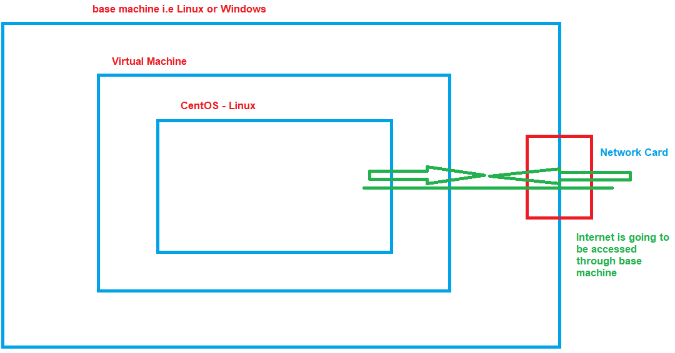
* $ ping [google.com](http://www.google.com)
* Open cmd in windows and run ipconfig” to display IP of base machine and Default Gateway
* **In case of a Linux base machine command is $ ip r l**
* 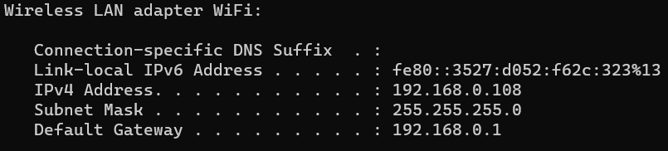
* 192.168.0.108 is IP of base Machine
* 192.168.0.1 is Default Gateway
* 129.168.0 is called network
* 108 is main IP address
* 192.168.0 this part will remain same during configuration
* We need a free IP to connect internet
* In this case we r going to use 109 0r 110
* To check it availability
* > ping it in main machine
* Text

  Description automatically generated
* Request time out means its not in use and a free IP
* 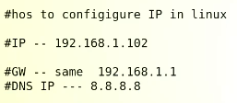
* Do not set DHCP 🡪 DHCP means manage settings from internet routher
* Troubleshooting if IP is not showing up in $ ip r l
* 